# PayRoll System REPORT

(Project Term Mar-April, 2020)

|  |  |  |
| --- | --- | --- |
|  | Submitted by |  |
|  |  |  |
|  |  |  |
| **RAHUL GUPTA** |  | **11602822** |
| **SHALINI TIWARY** |  | **11602518** |
|  |  |  |
|  |  |  |
|  |  |  |
|  |  |  |
|  |  |  |
|  |  |  |
|  |  |  |

#### Course Code INT402

Under the Guidance of

#### (Mrs Ankita Wadhawan Assistant Professor)

**School of Computer Science and Engineering**



**DECLARATION**

We hereby declare that the project work entitled Pay Roll Manangement System is an authentic record of our own work carried out as requirements of Pay Roll Project for the award of B.Tech degree in Computer Science and Engineering from Lovely Professional University, Phagwara, under the guidance of Mrs. Ankita Wadhawan , during March-April 2020. All the information furnished in this project report is based on our own intensive work and is genuine.

Project Group Number: KE027

RAHUL GUPTA 11602822

SHALINI TIWARI

11602518

10-04-2020

**CERTIFICATE**

This is to certify that the declaration statement made by this group of students is correct to the best of my knowledge and belief. They have completed this PayRoll Project under my guidance and supervision. The present work is the result of their original investigation, effort and study.

**Mrs.Ankita Wadhwawan**

**Assistant Professor**

**School of Computer Science and Engineering,**

Lovely Professional University,

Phagwara, Punjab.

10-04-2020

**Introduction**

### Purpose

The purpose of this document is to present a detailed description of PayRoll Project It will explain the purpose and features of this project, the various modules of the project, what this webpage will offer and the constraints under which it must operate. Employee wise salary report. We have use crystal report for generate salary slip of employee.

### Application Scope

Payroll management system concept used in many organization, where they have to manage employee, worker detail, manage leave and salary.

**This Asp.net webpage is new to the market in its own facility and connectivity. It is more ensured in form of keeping a secure information of its employee.**

# Overall Description

### Application Perspective

Employee payroll system used for manage employee detail and manage employee leave and generate employee salary and generate reports and salary pay slip.

Through this webpage people would get a more helping wages employee and in a very fast manner all the processing can work on. This webpage is also more secured and helpful for all the in need of employee details.

### Design and Implementation Constraints

Data would be collected in the register page of the webpage where user needs to enter the details needed for the Worker to be up for benefitting for others. It is a webpage which is designed is such a manner that user can interact with the system. Pay roll Webpage is having various options like login , profile settings , organization. Slip and salary.

### 2.5 Assumptions and Dependencies

For the proper working of the system we are listing our assumptions and dependencies as follows:

* + - A proper internet connection is required for the working of the webpage and to fetch

|  |  |
| --- | --- |
| **Project Type :** | Website |
| **Technology :** | ASP.Net Visual Studio 2012 with C# Language |
| **Database :** | SQL-Server 2008 |

## Payroll System Project Overview

The main concept we cover in our system is manage employee detail, manage leave, Generate monthly salary, Extra Allowance and Deduction.

Admin is a responsible for operate whole system.

Admin has rights to Add new Employee, Each employee has a unique username and password to login in to system.

After login in to system all employee can apply for a leave with valid reason.

The admin can check leave and he can approve and reject employee leave.

According to approve leave the leave deduction will be deducted from salary.

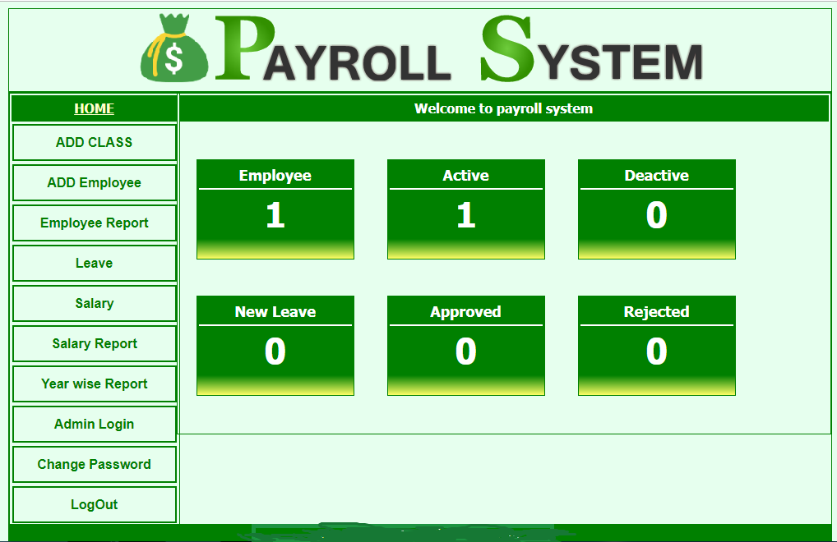

## Payroll System Project Modules

* Employee Management
* Leave Module
* Allowance and Deduction
* Salary Module
* User Account

### Employee Management

Admin can add new class, add new employee and manage employee detail. Each employee has unnique username and password for operate the system.

### Leave Module

Employee can apply for leave after login to system. Admin can respond leave by approve or reject. Employee can check his leave status it would be approve or reject.

### Allowance and Deduction

At the time of salary generation Admin can set manually HR, DA, Travel, Medical, Washing Allowance for each employee.Leave will be deducted from salary.

### Salary Module

Admin can generate month wise salary for each employee one by one and generate salary pay slip.

### User Account

Create new admin account with username and password for operate system.

There are main two users who operate the system.

* Admin
* Employee

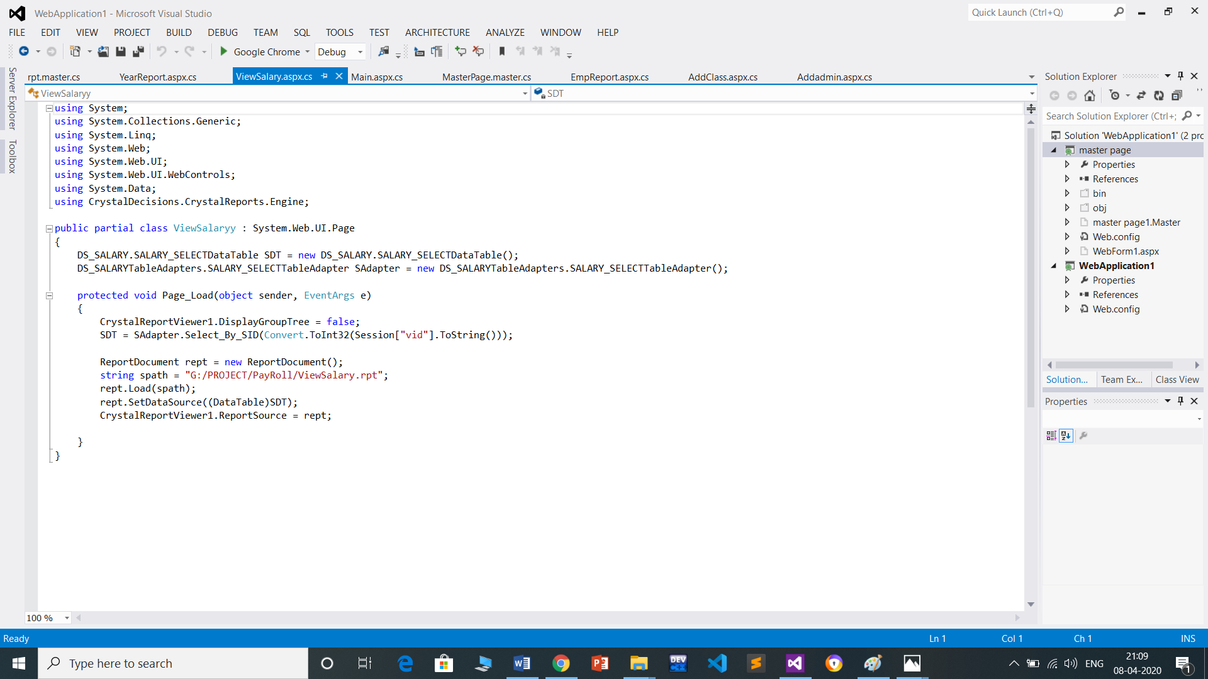

**Snapshots of source code**



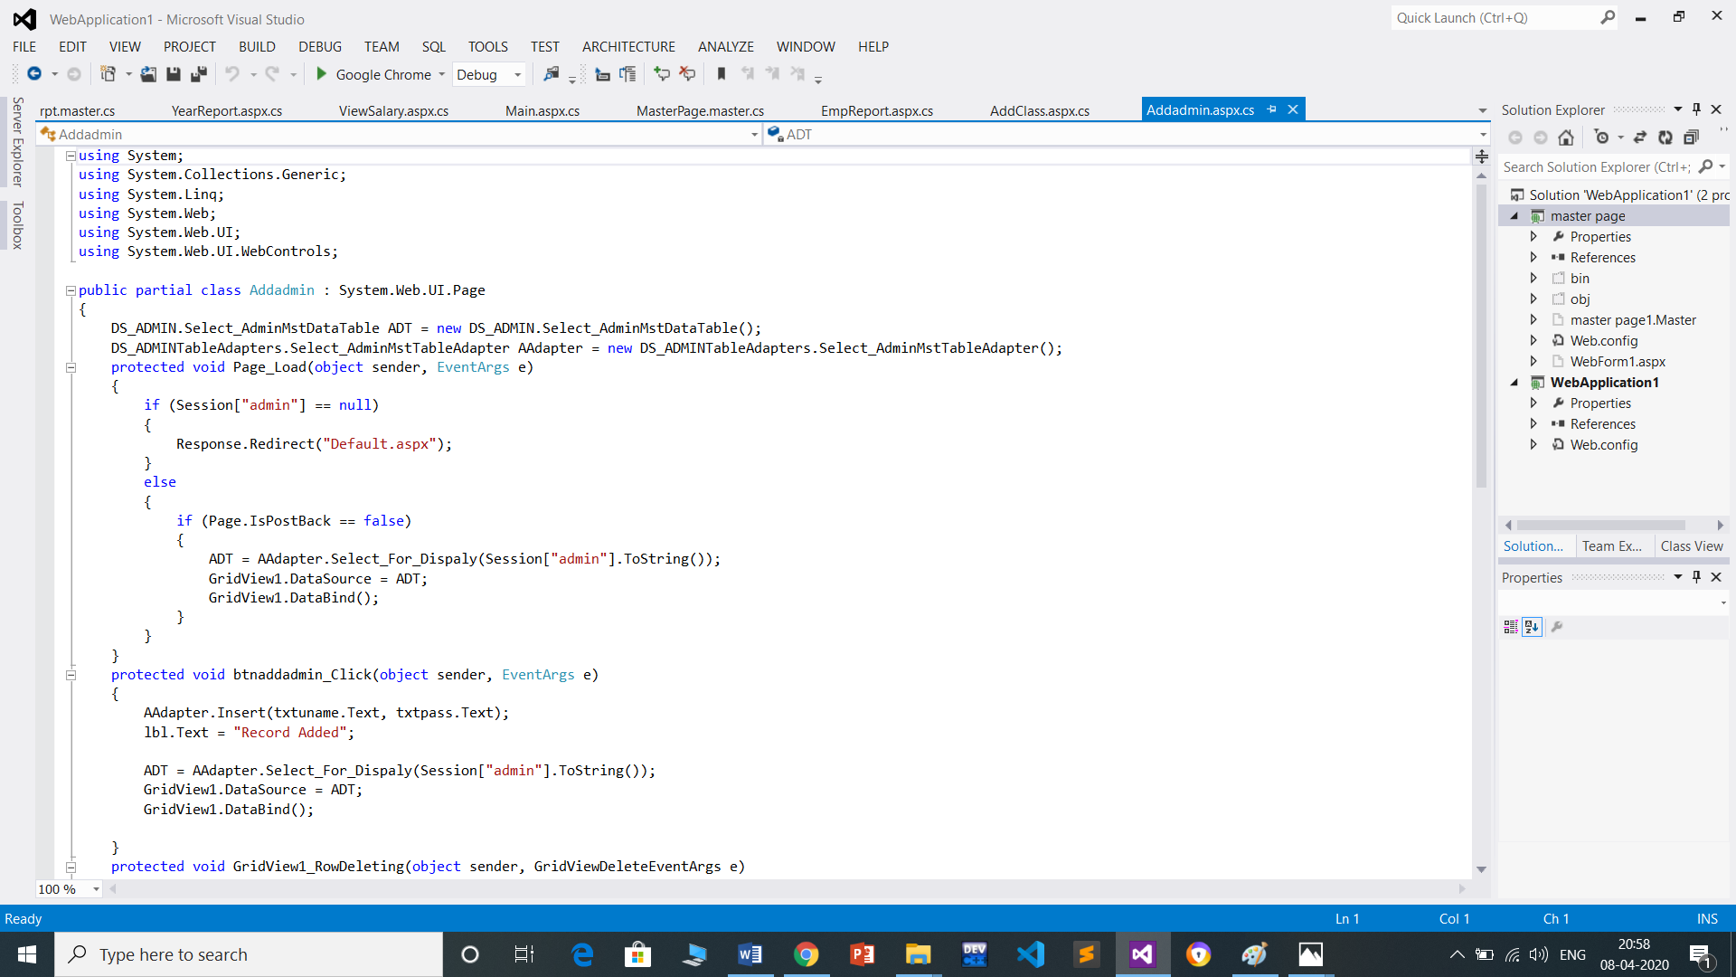

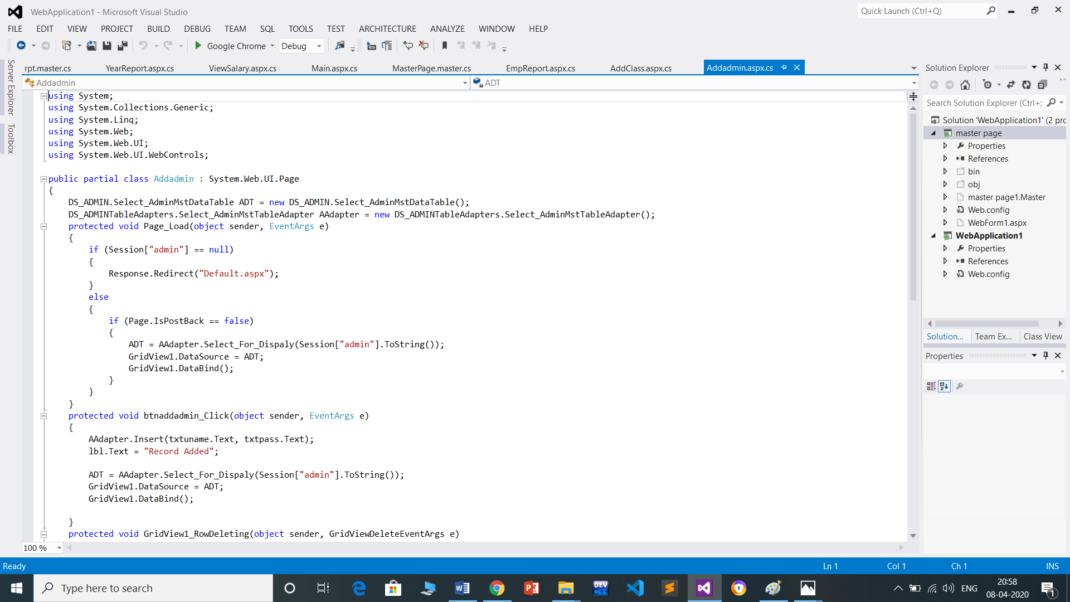

## Admin Functionalities

* Add Class
* Add employee
* Manage Leave
* Set HR, DA and Allowance
* Generate Salary
* Generate Pay Slip
* Create New Admin
* Change Password
* Employee Report
* Leave Report

## Employee Functionalities

* Apply Leave
* Leave Report
* Salary Report
* Print Salary Slip
* Change Password

# At the time of generate salary we can manually set Travel Allowance, Medical Allowance, Washing Allowance and Calculate HR and DA. Admin can generate and view Employee Report, Leave Report, month wise salary report, year wise salary report, Employee wise salary report. We have use crystal report for generate salary slip of employee.

# C:\Users\Rahul\Pictures\Screenshots\Screenshot (11).png

# 

# 

# ER Diagram – Payroll System

E-R (Entity-Relationship) Diagram is used to represents the relationship between entities in a table. ER diagrams represent the logical structure of databases. ER Diagram represent relationship between two database tables.

E-R diagram means Entity Relationship diagram. Entity is a object of system, generally we refer entity as database table , the e-r diagram represent the relationship between each table of database. E-R diagram represent entity with attributes, attributes is a properties of entity. If we assume entity is a database table then all the columns of table are treat as attributes.

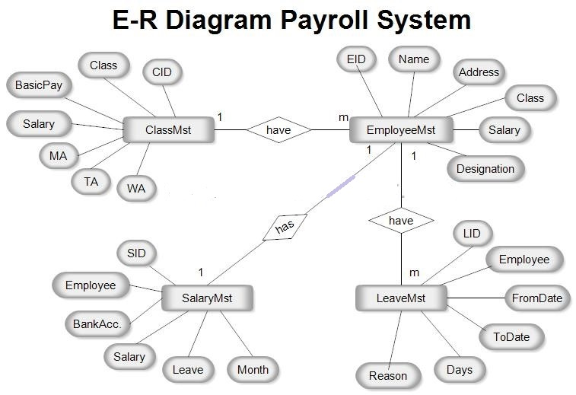

**DATA flow diagram of payroll system**

